**ECOBRIDGE**

An automated knowledge-based workflow for spatial downscaling

Josep Serra Gallego, Hollie Blaydes, Emma Gardner, Richard F. Pywell, J. Duncan Whyatt, John W. Redhead

**Highlights**

* ECOBRIDGE is an ArcGIS Pro workflow to downscale scenario land cover/use maps
* ECOBRIDGE uses expert knowledge in a flexible, rule-based system to create finer-resolution outputs
* The workflow includes an optional Deep Learning module to facilitate knowledge sharing
* The workflow has been extensively tested and is available as an ArcGIS Pro toolbox

Abstract

ECOBRIDGE (**Eco**logy and **B**iodive**r**sity **I**ntegrated **D**ownscale **Ge**neration) is an open, knowledge-based ArcGIS Pro workflow, to produce high-resolution land cover/land use (LC/LU) maps from coarser sources. Present day mapping captures fine LC/LU details, but future/alterative LC/LU scenarios are typically constructed at coarser spatial resolution, hindering comparisons. ECOBRIDGE draws on specialist knowledge to parse a low-resolution baseline and scenario, a higher-resolution baseline and information defining LC/LU change, to generate high-resolution spatial data for the scenario.

These outputs are produced in the form of two datasets: as a raw pixel map and as an intelligent mapping layout which considers the structure of the landscape. ECOBRIDGE also facilitates the transfer of knowledge from a human-dependent expert system to an AI framework by packaging the downscaling process into a transferable deep learning model.

The datasets created by ECOBRIDGE can contribute to more detailed analysis, bridging the gap between low-resolution datasets and more precise high-resolution information.

1. Introduction
   1. Land Use and Land Cover (LULC)

The way that humans use and modify the earth’s surface is one of the most fundamental drivers of our impact on the planet. Categorising these drivers has resulted in the interlinked concepts of Land Cover (LC) and Land Use (LU). These terms have often been used interchangeably (A. Comber, 2008), even if the consensus (Verburg et al., 2004, 2006) is that these are two very different concepts (Verburg et al., 2004, 2006). Generally, LC is defined (García-Álvarez et al., 2022) in terms of the natural, biological, and physical components that can be found on the surface of the Earth (for example, water, rock, sand, etc.) while LU relates to how societies employ the land in question (García-Álvarez et al., 2022). Alternatively, LC can be detected by Earth observation means, while LU identification needs social, economic, and even historical interpretation (A. J. Comber, 2008). However, these concepts are very tightly linked, since the activities that humans perform on the land (LU) are strongly determined by the natural materials which can be found on it (LC), with complex relationships existing between LC and LU (A. Comber, 2008). It is therefore appropriate to consider the two concepts in tandem.



* 1. Land Use and Land Cover Change (LULCC)

Whilst changes in LU and LC have taken place throughout the history of humankind (Hassan et al., 2016), the pace of change is accelerating with almost a third (32%) of the global land surface affected over the past six decades (Winkler et al., 2021). Currently, Land Use and Land Cover Change (LULCC) is driving transformation in ecosystem biodiversity, soil composition and degradation, and species distribution (Dendoncker et al., 2006), flood risk (Zhu et al., 2019), air quality (Mccarty & Kaza, 2015), and other environmental phenomena. These changes are, in turn, driving economic, social and political transformations (Lambin et al., 2003). LULCC is also closely linked to climate change, since a changing environment affects what land covers are possible as well as the way land is used, and LULCC can also be a climate change driver or mitigator (e.g. via creation or restoration of carbon-sequestering land covers).

* 1. Modelling LULCC scenarios

The relevance of LULCC for 21st century societies has, in turn, highlighted the importance of developing techniques for detecting, analysing and forecasting these transformations. While LULCC monitoring and exploration has been boosted in recent years by the advancement and increased affordability of satellite technologies (Walsh et al., 2024), (Yu et al., 2011) and Unmanned Aerial Vehicles (UAVs) (Kleinschroth et al., 2022), these new technological advancements do not provide trend detection or forecasting of future LULCC by themselves (Chen et al., 2019). Modelling complements these remote sensing technologies and allows us to detect drivers, explore dynamics, and analyse what-if LULCC scenarios (Verburg, Overmars, et al., 2006). Scenario approaches do not attempt to predict the future, but instead aim to explore multiple potential futures, to gain a better understanding of the range and uncertainties of the potential pathways and impacts of LULCC (Audsley et al., 2006), (Moss et al., 2010). Scenarios help to prioritise further research and identify LULC policy options (Audsley et al., 2006), but vary widely in their aims, the systems to which they are applied and how they are constructed. For example, scenarios can be based on economic or non-economic factors (Overmars et al., 2007), may be spatially explicit or not (Ren et al., 2019; Verburg & Veldkamp, 2004), and can be statistical/empirical (Sun & Robinson, 2018) or based on rules (Verburg et al., 2004b). There are many tools to create scenarios and to translate scenario narratives into quantifiable changes in LULC (Audsley et al., 2006), (Britz et al., 2011). Many scenario developers then produce spatially explicit realisations (i.e. maps) of LULCC, which allow the exploration of spatial variation in scenario outcomes, the evaluation of context dependent outcomes and allow for scenario impacts on environmental and socioeconomic outcomes to be modelled via tools which require such spatial data as inputs (Finch et al., 2021). As a result, there are many existing LULC maps available, from a wide range of scenarios, generated by a wide range of methods (Friedl et al., 2022), (Zhang et al., 2023).

* 1. Downscaling

Traditionally, most methods and models that allow the production of spatially explicit LULCC scenarios produce outputs at low spatial resolutions, typically equivalent to 1km x 1km or coarser. This is generally because scenario generation models are computationally expensive, so running them at finer scales is costly in terms of time or computational power, and because reliable data on the drivers and constraints of LULCC at finer scales is often lacking (e.g. the ownership and management of individual land parcels). However, this places limitations on the use of these outputs for practical applications at the local level (Friedl et al., 2022). A lack of high-resolution output predictions can also lead to under or overestimation of model output (Woodman et al., 2023) and limits our ability to simulate many environmental processes that are highly dependent on fine-scale spatial context (Giuliani et al., 2022), (Houet et al., 2017).

In recent years, the increase in computing capacity, new modelling approaches and higher-quality baseline LULC datasets, combined with a bigger demand for LULCC models and applications, have meant that downscaling methods for higher-resolution LULC scenario maps are being developed. These systems employ different strategies to generate fine resolution data from lower resolution information. Many use statistical or probabilistic methods: e.g. Hoskins et al (2016), Bardossy et al. (2005), Bürger & Chen (2005), Giuliani et al.(2022). Other approaches have also been identified, including the use of integrated assessment models (West et al., 2014), but the main alternative approach to statistical downscaling strategies is the use of rule-based methods. Designers of rule-based methods have often combined expert knowledge with interpretations of spatial storylines, analysis of past LULCC, and high-resolution datasets (Rickebusch et al., 2011). This knowledge, the core of rule-based strategies, is often expressed as *transitions* (Le Page et al., 2016): change vectors governing how data will be transformed from low-level to high-level resolution.

* 1. Aims

ECOBRIDGE aims to provide a flexible, rule-based workflow for downscaling existing coarse-scale spatially explicit LULC scenario outputs to finer resolutions. We have developed ECOBRIDGE to fill the need in the environmental and ecological sector for a flexible system that can provide high-resolution datasets from coarser sources by integrating transferable scientific knowledge channelled in the form of transition rules. We structured the rule-based design of ECOBRIDGE into what can be described as an expert system. Expert Systems are part of the wider domain of Artificial Intelligence. They are designed to emulate the way expert humans carry out some tasks (Lucas & Van Der Gaag, 1991). At the core of Expert Systems there is a knowledge base, which contains the human expertise on the field in question, stored in a way that allows it to be used and processed efficiently. Expert Systems also include an inference engine, which is the set of rules and reasonings that drive the correct processing of the information in the knowledge base. ECOBRIDGE was designed to work efficiently over large (regional to national) extents and aimed at ensuring that the knowledge encapsulated in ECOBRIDGE was shareable and accessible to all. Additionally, like many developers of expert systems (Klyuchko, 2018), we also wanted to make a workflow which could be run in desktop-level devices such as minicomputers or dedicated workstations, but which would not require high levels of computing power or virtualisation.

Whilst the environmental and ecological sciences have benefitted from the advantages of expert systems (Warwick et al., 1993), (Hosseini-Moghari et al., 2015), (Loehle & Osteen, 198), (Chytrý et al., 2020), they are no longer the forefront of the AI revolution. Many Expert Systems are being gradually replaced by a new form of AI: Deep Learning. Deep Learning is a form of machine learning that focuses on automatic learning consisting of layers of convolutional neural networks (CNN) which are trained iteratively (Geron, 2019), allowing images to be interpreted in a way that mimics the human brain’s cognitive qualities. Most Deep Learning models are flexible, transferable and open. To include this functionality in ECOBRIDGE we added an optional Deep Learning model generator to the initial expert system design. This allowed us to guarantee that the expert knowledge employed for the creation of the transition table and the generation of the downscaled output can be used by other users in different contexts.

1. Methods

The ECOBRIDGE workflow was originally developed to downscale existing UK-extent 1km resolution scenarios (Malcolm et al., 2023) to finer resolutions that would allow input into process-based models of landscape use by a range of taxa (Gardner et al., 2024) and was based on a sequence of downscaling steps in ArcGIS applied by Blaydes et al. (in review).

* 1. Input LULC Maps

To characterise LULCC, ECOBRIDGE requires four different input spatial datasets:

* a low-resolution baseline,
* a high-resolution baseline,
* a low-resolution scenario,
* and a polygon dataset of landscape parcels.

The polygon dataset ensures that the output landscapes retain the realism of the way landscapes are configured into discrete units (e.g. agricultural fields) and avoids artefactual hard boundaries at the edges of low-resolution grid cells. A user could simply use a vectorised version of the high-resolution baseline if an independent representation is not available.

For our study, we used the Land Cover Map 2020 produced by UKCEH to supply requirements 1, 2 and 4. The Land Cover Map 2020 (LCM2020) is a suite of geospatial land cover datasets (raster and polygon) which describe the UK land surface in 2020. These were produced at the UK Centre for Ecology & Hydrology by classifying satellite images from 2020. We used the 1km (Morton et al., 2022a) (dataset 1), 10m (Morton et al., 2022b) (dataset 2), and polygon (Morton et al., 2022c) (dataset 4) land cover maps.

* 1. Scenarios

To develop and test our workflow, we used 1km resolution scenarios developed by Malcolm et al. (2023). These comprise 12 UK-extent LULC maps (11 scenarios plus a modelled baseline), with a thematic resolution similar to the ten Land Cover Map aggregate classes, but with additional classes introduced under scenarios (e.g. agroforestry, bioenergy crops). The LULC maps had been originally developed by rule-based extrapolation from LCM2020, so that spatial extent and resolutions aligned, and the classes followed the same numbering system. This allowed a robust test of the workflow, with large spatial extent, radical changes in LULC and the introduction of novel land use classes, without introducing complexities extraneous to the workflow (e.g. recoding LULC classes, matching spatial extents, projection and resolutions).

* 1. Expert Knowledge and Transition Table

Rule-based downscaling models use *transitions*, i.e. sets of user-led conditions which define how changes will occur from an initial state to its projections under a given scenario (Lucas & Van Der Gaag, 1991). In our workflow, these transitions are defined in the form of a comma separated values (CSV) file provided by the user. We refer to this as the transition table. This is the fundamental route by which expert knowledge on LULCC is used to parametrise the workflow. It can be constructed by researchers and/or practitioners coming together to decide which LULCC transitions are likely to happen in real life and which land covers are unlikely to change, informed by local knowledge and/or by examination of historic changes (e.g. Redhead et al 2020).

Table - Sample transition table, first three rows. The transition table used for testing and development of ECOBRIDGE had over 300 rows/rules.

|  |  |  |  |
| --- | --- | --- | --- |
| Low-Resolution Baseline Class | Low-Resolution Scenario Class | High-Resolution Baseline Class | High-Resolution Downscaled Class |
| 2 | 6 | 1 | 1 |
| 2 | 6 | 2 | 6 |
| 2 | 6 | 3 | 3 |

In ECOBRIDGE, the first row of the transition table CSV file is reserved for headers. These are entirely customisable by the user – ECOBRIDGE does not use the information in the header. In addition to the header row, the transition table must consist of 2 pairs of 2 columns. The first pair (Table 1, Low-Resolution Baseline Class and Low-Resolution Scenario Class) indicates the transition from the low-resolution baseline (column 1) to the low-resolution scenario (column 2). The second pair of columns deals with how high-resolution spatial data within that low-resolution transition (column 1 – column 2) will change from the high-resolution baseline (column 3) to the high-resolution scenario projection (column 4).

For instance, the first row in Table 1 indicates that, in low-resolution baseline pixels classified as class 2 which become class 6 pixels in the low-resolution scenario projection, high-resolution class 1 pixels remain unchanged. However, in the second row, under the same low-resolution circumstances, class 2 high-resolution pixels become class 6 pixels.

* 1. Overarching workflow and development environment

At ECOBRIDGE’s core is a geoprocessing workflow built on ArcGIS Pro’s Modelbuilder programming platform (Figure 1). Modelbuilder provides a flexible, interactive platform on which developers can chain geoprocessing workflows and scripts. The main geoprocessing workflow is complemented by four additional python scripts, and a secondary workflow for auxiliary iterative processing during the extraction stage.

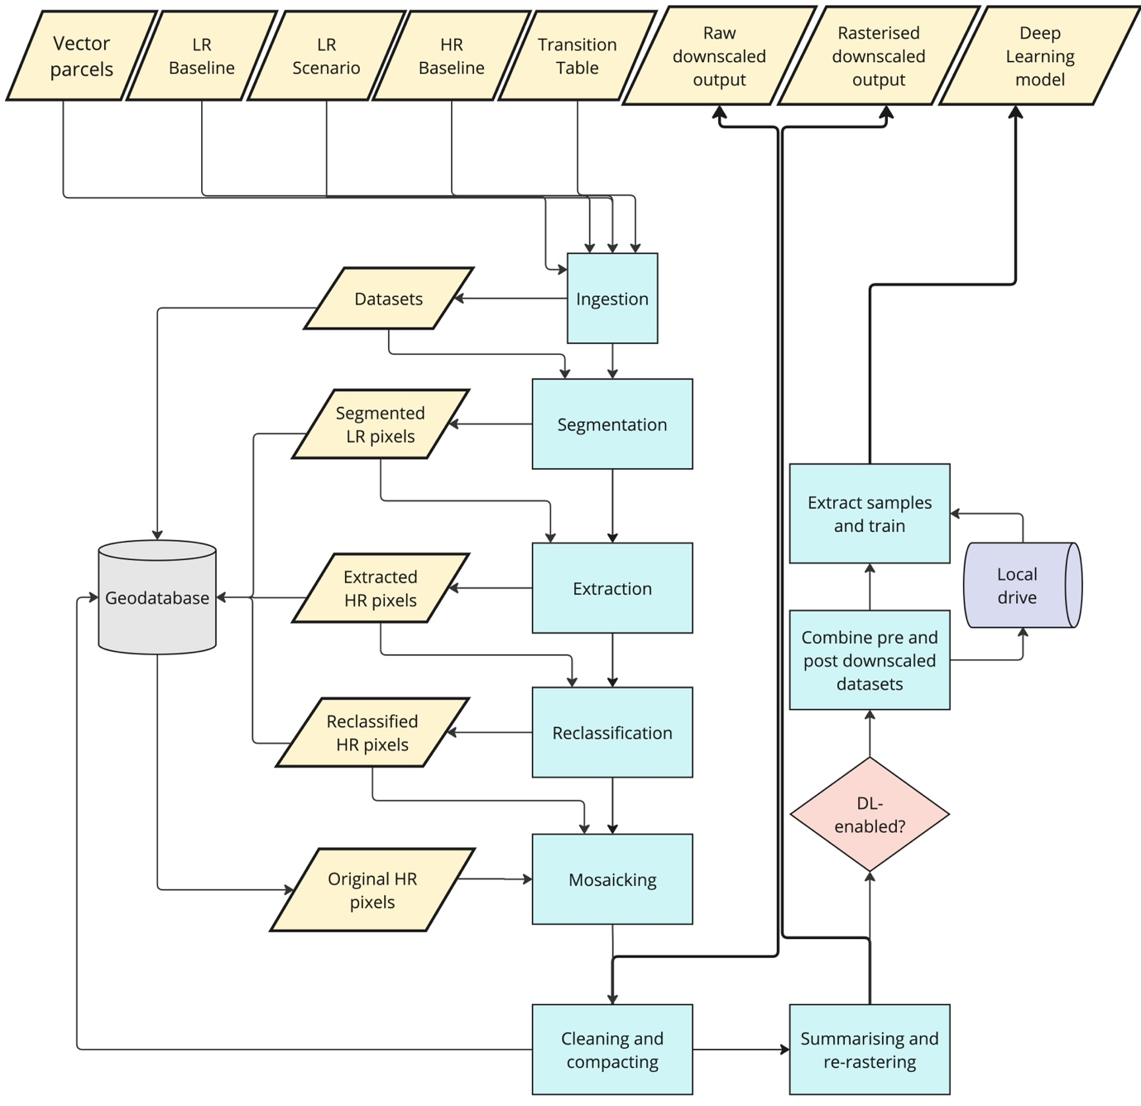

Figure - Simplified flowchart of the ECOBRIDGE core workflow design.

LR: Low Resolution, HR: High Resolution, DL: Deep Learning.

The downscaling workflow and algorithms at the core of ECOBRIDGE have been designed on the ArcGIS Pro environment. They have been tested and validated using the 3.2 version of the platform. Compatibility with other builds, particularly older versions, is not guaranteed. We used ArcGIS Pro Advanced edition, with the Spatial Analyst and Image Analyst extensions.

The ECOBRIDGE workflow has been run on both desktop (Windows 10 and 11) and virtualised environments successfully. Virtualisation has been carried out on a Parallels VM from a Mac OS host. To guarantee an accelerated performance, the ArcGIS Pro development environment for ECOBRIDGE was set up with a configuration which included disabling the automatic generation of raster pyramids and using GPU processing by default. Before running ECOBRIDGE, it is recommended that users verify that the source datasets are aligned and share the same coordinate system. It is also recommended that the processing extent mirrors that of the required area of analysis. In ArcGIS Pro, this involved making sure that the environment Snap variable was configured to match one of the low-resolution datasets, and this is recommended best practice for this and similar platforms. This allowed us to guarantee that the results of the different stages of the workflow were aligned correctly to the source of change: the transitions at low-resolution level. Before executing the workflow, it is recommended to visually verify that the different layers align correctly using a map view.

* 1. Geoprocessing workflow

The ECOBRIDGE workflow starts by ingesting all required spatial inputs. In later stages of the workflow, the polygon dataset will be used to rearrange the raw reclassified pixels into structures that reflect the real landscape layout. By default, inbound image datasets are wrapped into an eight-bit Esri pixel grid.

Next, the transition table is ingested. The workflow expects the transition table to be a CSV file of four columns of integer values. The first two columns of the transition table are read, isolating the individual low-resolution transitions (column 1 and column 2). Then, for each individual pair of low-resolution transition values in columns 1 and 2, the pixels that match these values from the low-resolution baseline (column 1) and the low-resolution scenario (column 2) are extracted using arcpy ExtractByAttributes function, saving the output into two auxiliary raster files, which include the extracted values from column 1 and 2, respectively. Then, these two auxiliary raster files are subtracted. In the arcpy environment, raster subtraction only returns a numeric value if the pixels for both operands are numeric. Thus, subtracting the extracted raster files produces a raster file where overlapping pixels produce a numeric output, while the rest of the cells are Null. This allows us to map cells where a matching transition has taken place. The actual numeric result of the subtraction is irrelevant – only the spatial attributes of overlapping cells are significant. The datasets resulting from the subtracting operations are stored in the geodatabase.

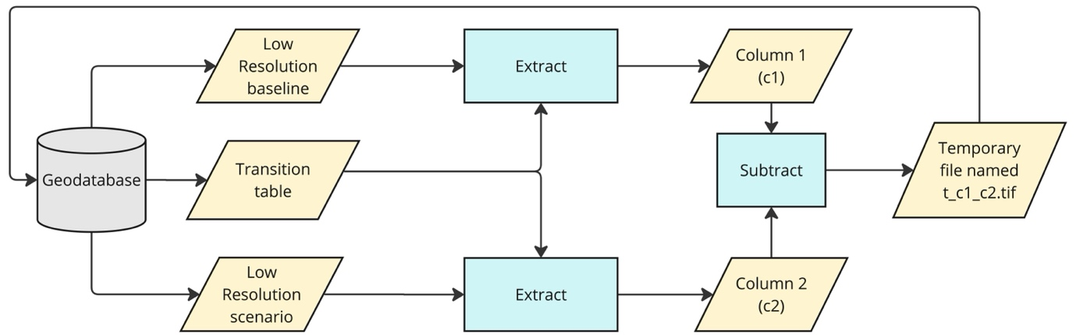

Figure - Simplified flowchart of the segmentation stage

The workflow then iterates through the geodatabase and vectorises the raster datasets resulting from the subtraction process to create a series of templates or masks. These masks, which match the location of each individual low-resolution transition, are then applied to the high-resolution dataset: they are used to clip it. These sections of the finer baseline are stored into the local main ArcGIS Pro geodatabase as individual raster datasets and are labelled in a way that reflects the low-resolution transitions that originated them to enable their identification in the next processing step.

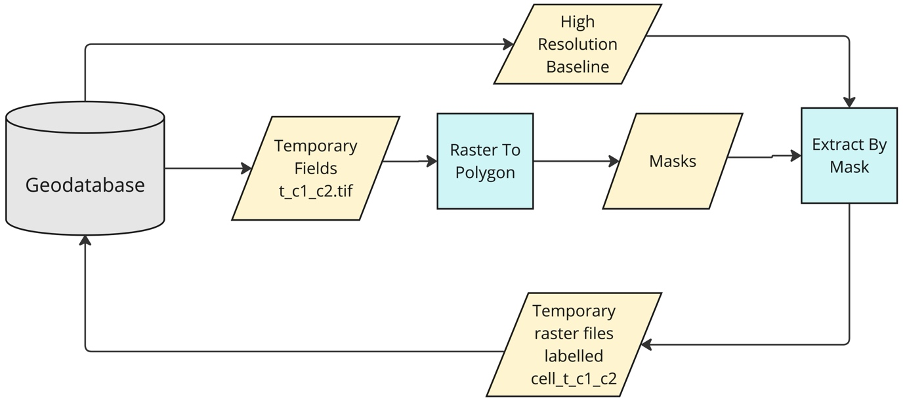

Figure – Simplified flowchart of the extraction stage

Through this labelling, ECOBRIDGE can establish the low-resolution transition which originated each cell and, by revisiting the transition table and parsing the values in columns 3 and 4, can determine which high-resolution transitions should be applied to them. Thus, driven by the chains of changes specified in the transition table, cells undergo a pixel reclassification process. Once this process has been completed, ECOBRIDGE runs a cleaning routine to delete previously created segmentation raster files, to free memory space and boost execution speed.

Next, ECOBRIDGE combines the reclassified clipped cells, overlaying them on the original fine-resolution baseline. In this way, areas without changes keep existing values: the reclassified areas are slotted into the correct locations, creating a complete mosaic of reclassified and original datasets. The resulting mosaic is the raw downscaled dataset, which is stored in the geodatabase as downscaled_output_RAW.tif.

At this stage, another cleaning routine is activated, and the remaining auxiliary datasets created during the execution (temporary segmentations, feature classes used as templates or masks, and automatically generated ArcGIS raster extractions) are deleted. This optimization is complemented by an additional process, which consists of compacting the geodatabase to optimise performance.

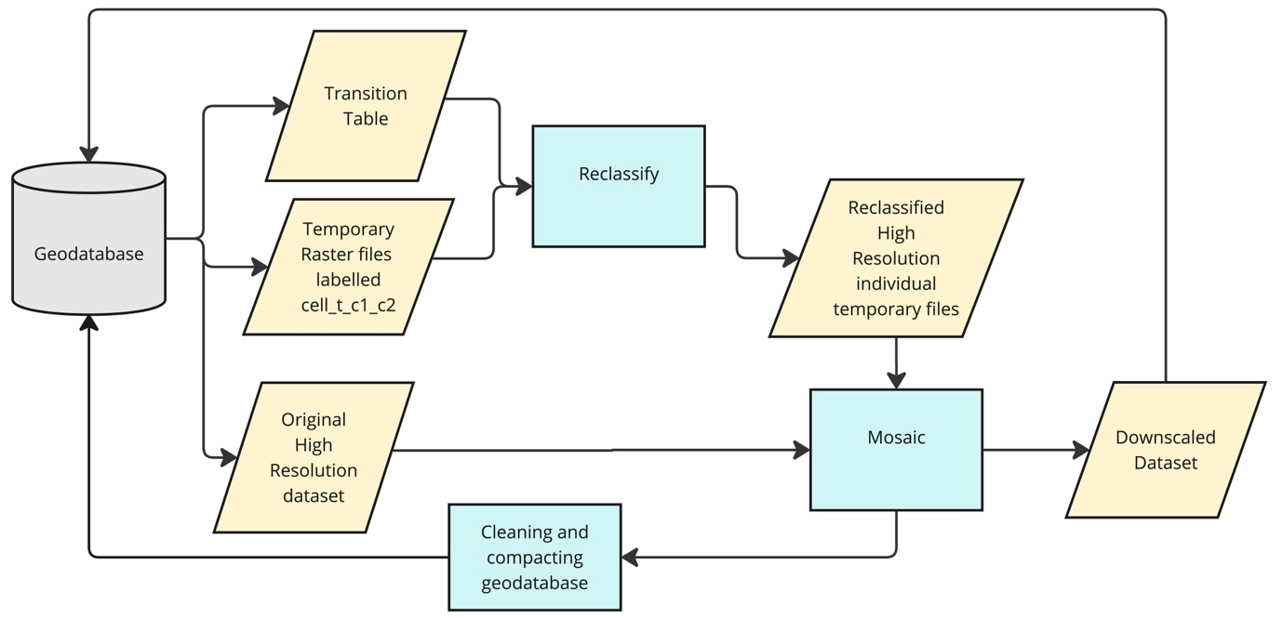

Figure – Simplified flowchart of the reclassification stage

The ECOBRIDGE workflow uses zonal statistics to summarise the higher-resolution majority pixel count for the downscaled output dataset, in relation to each parcel in the ingested polygon dataset. Once these figures have been calculated, the polygon data is updated and finally, a rasterization function is called to turn this feature class dataset into a final raster file at the finer resolution: the resulting file keeps the landscape structure, but it also includes the downscaled information.

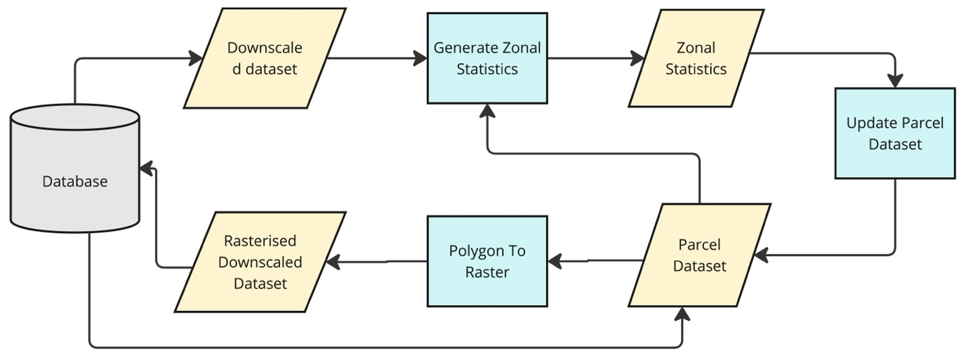

Figure - Simplified flowchart of the rasterisation stage

* 1. Creation of the Deep Learning model

Finally, with the two completed downscaled datasets, the user can opt to create a Deep Learning model to package the knowledge used in the creation of the new high-resolution scenario output in a widely compatible format. The production of this Deep Learning model is not automatic since it requires a different set of licences (Image Analyst and Deep Learning libraries) from those to produce the downscaled datasets. Thus, the Deep Learning model generator has been encapsulated in a secondary Modelbuilder-based workflow (named *unet_model_generator*). This workflow employs the same land cover datasets as before, and it also ingests the newly created downscaled dataset. It combines the four land cover datasets into one single raster dataset (L4) which includes all pixel combinations. To comply with ArcGIS Pro Deep Learning formatting protocols, the dataset attributes are then modified and summarised in two new attributes: a *classvalue* field, with the different values for each of the four layers’ combinations, and a *classname* field, with the corresponding label for the combination. The workflow then carries out a second raster combination, this time without considering the downscaled dataset. This dataset combines the initial, known raster datasets (L3).

The workflow then calls the Export Training Data For Deep Learning function and using the vectorised L4 dataset as labelled samples and L3 as input raster, it generates training samples and metadata in classified tile format: this format is necessary to train our chosen Deep Learning model. The training samples are then used to train a UNet Deep Learning model which is finally exported, together with the information to interpret it.

ECOBRIDGE creates a folder in the C: drive called ECOBRIDGE which includes two additional subfolders: SAMPLES (with the results of the Export Training For Deep Learning function) and MODEL, with the new UNet model, ready to be used for further classification tasks. Users can train the model further using the output UNet model and the contents in the SAMPLES folder as a base for further training on any compatible AI platform.

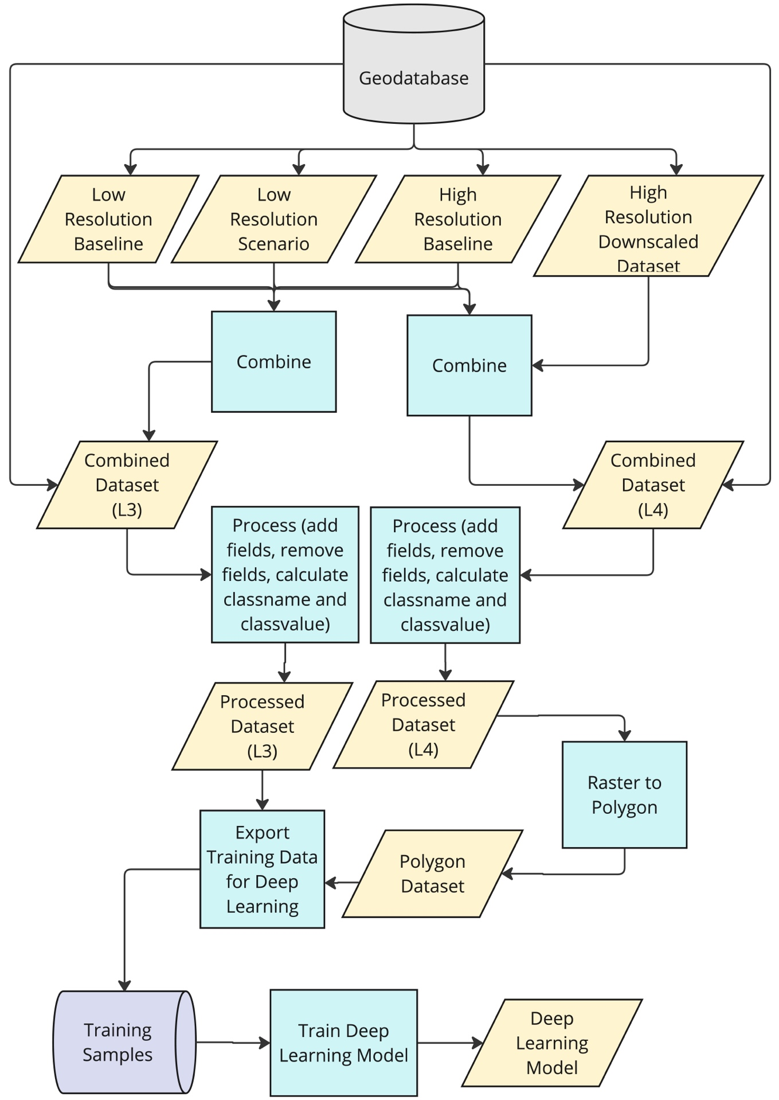

Figure – Simplified flowchart of the creation of training samples and UNet deep learning model

1. Results
   1. ECOBRIDGE interface and execution

ECOBRIDGE can be accessed as an ArcGIS Pro toolbox within the ESRI platform of spatial software services. Users can integrate it into their ArcGIS Pro working environment: this integration can be carried out locally by accessing the .atbx file with the tools code or, if the users belong to the same organisation, through the ArcGIS Online platform environment. The tool User Interface is a simple menu which consists of five textboxes and a Run button. The different parameters can be dragged and dropped to the corresponding component, or they can be found by browsing through the folder system. In addition to specifying the different datasets needed to run the ECOBRIDGE workflow, users are also advised to plot them in ArcGIS Pro and make sure that the projections and processing extent are correctly configured.

Figure - ECOBRIDGE Graphical User Interface

ECOBRIDGE’s execution running time depends on the datasets being processed, the transitions being implemented, and the equipment used. On a high-end GPU-enabled device, processing datasets covering the whole of the UK consistently took approximately 6 hours. The creation of the Deep Learning model took approximately 20 minutes per iteration. The user is informed of the software progress by a constant feed of messages indicating the stage at which the workflow is, and the operation being carried out.

The results of the execution of ECOBRIDGE are best exemplified in Figure 8 and Figure 9 below. Figure 8 shows a 10 class, 1 km x 1 km Land Cover baseline for a sample area of Southern England (top right, A), and the 12 class scenario output for the same area (bottom left, B). In this, the increase of broadleaf and coniferous woodland is evident, together with the introduction of new land cover classes such as silvoarable regions in the north of the image. The bottom right image (C) in Figure 8 shows the high-resolution (10 m) map for the same area. In Figure 9, the changes driven by the baseline-scenario transitions are apparent in the increase of woodland to the detriment of improved grassland and arable land cover, and, to a lesser measure, in the presence of silvoarable cover. The top row (D, E) is also characterised by the presence of square patterns and sharp edges where transitions occurred and land cover in contiguous regions differ, while the bottom row (F, G) shows how the application of the rasterisation process of ECOBRIDGE helps to mitigate the appearance of sharp edges in the downscaled output. ECOBRIDGE reclassifies all polygons in the parcel dataset using the predominant underlying pixel class. Thus, it helps restore the original landscape features, delivering an artifact-free, natural-looking downscaled dataset.

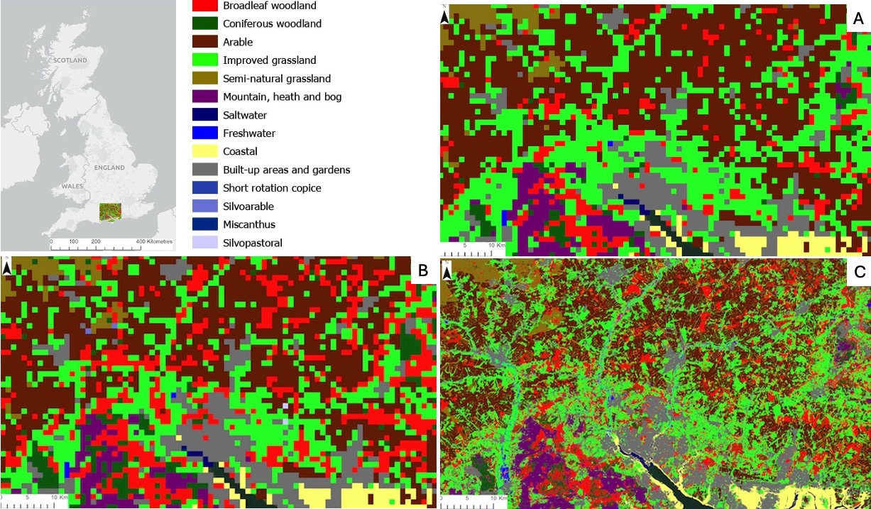

Figure – Legend and map showing location of the testing and validation area (top-left). The remaining three panels show input datasets to ECOBRIDGE: A) Low-resolution baseline, B) low-resolution scenario input , C) high-resolution baseline

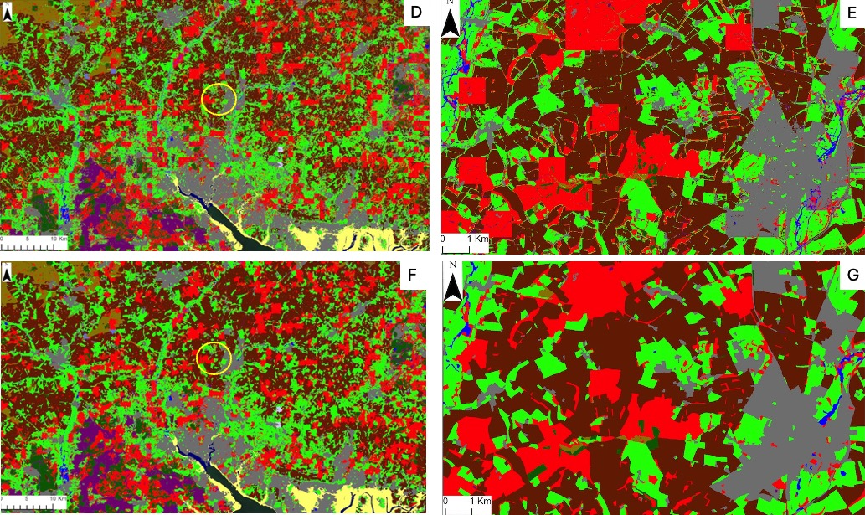

Figure - Top row (D,E) shows raw downscaled output from ECOBRIDGE (D), with close-up view of yellow circled area (E). Bottom row (F, G) shows re-rasterised downscaled output (F), with close-up view of yellow circled area (G).

* 1. Deep Learning model results

ECOBRIDGE’s Deep Learning Training process was run for 20 iterations and used a resnet34 model as backbone. The Deep Learning model was shown to achieve accuracy levels of over 76%. Figure 10 is an example of the results obtained by applying the trained Deep Learning model to the original high-resolution baseline dataset.

While the Deep Learning model it is not a direct substitution for the ECOBRIDGE expert system, it is an alternative tool for users who can’t access ESRI’s platform but want to benefit from the ECOBRIDGE knowledge transfer abilities to carry out the scenario output downscaling processes.

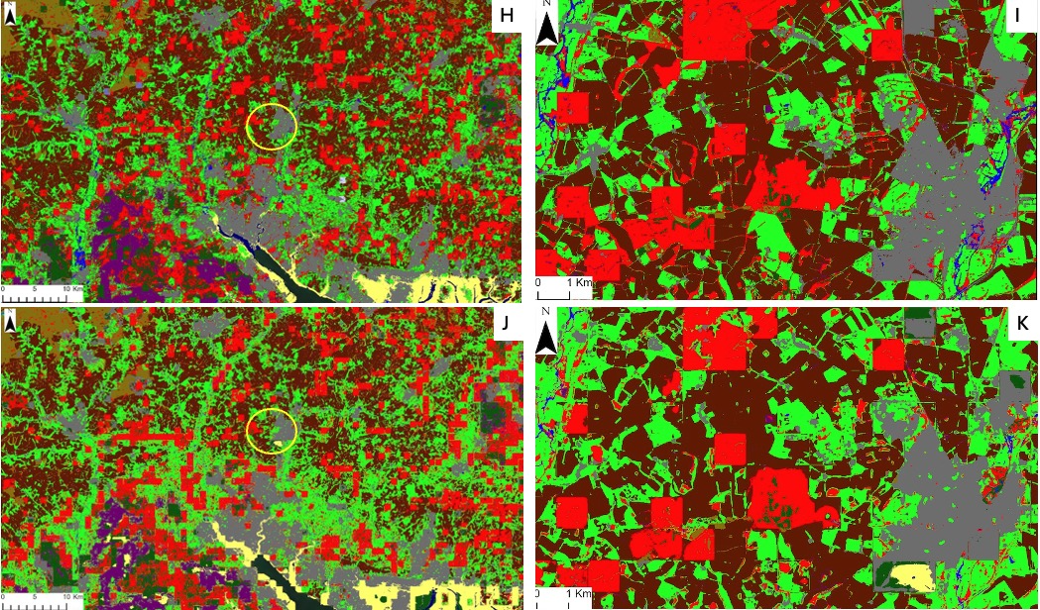

Figure - Top row shows raw downscaled output (left, H), with close-up view of yellow circled area (right, I). Bottom row shows downscaled output produced by the DL model (left, J), with close-up view of yellow circled area (right, K)

1. Validation

The ECOBRIDGE workflow has been validated following a qualitative and quantitative approach, focusing on the detection of unwanted results or anomalies. The validation process cannot *per se* determine whether the changes that occur through the datasets are correct (since scenarios produce hypothetical change and we have no actual change against which to compare it) but can help us confirm that all expected changes take place, that no changes take place in an unanticipated way and the ability of the tool to handle unexpected inputs in the transition table.

* 1. Qualitative validation

Qualitative validation consisted of carrying out a visual assessment of the downscaled results. This involved manually inspecting the four raster datasets, identifying the different transitions at play in both low- and high-resolution datasets, and checking that the expected value changes took place. This process lacks the automation and comprehensiveness of statistical or software-based methods but, like other authors particularly in the field of Earth Observation (Pulla et al., 2023), (Abareshi et al., 2022), we found that this was a crucial step during the initial stages of development of the ECOBRIDGE workflow to verify that pixels were selected/omitted correctly for each given transition.

To carry out this manual verification of results we used the Create Accuracy Assessment Points workflow in the ArcGIS Pro Image Analyst dataset. A total of 500 accuracy assessment points were plotted on a section of the downscaled output of approximately 7,500 km2 in Southern England. Randomly distributed points were created for each class, according to the proportional area of the class. Zonal statistics were calculated for each accuracy assessment point to establish their overlapping pixel at different scales.

* 1. Quantitative validation

Additional checks were carried out to verify the correctness of the results. For example, we compared the changes in pixel counts between the low-resolution baseline and the scenario output datasets, and the changes which occurred between the high-resolution baseline and downscaled data. These changes were compared across the two groups and datasets. As expected, proportional total count variation on the low-resolution datasets were mirrored by similar changes in the high-resolution images to within ±5%.

Figure – Bar plot of percentage cover of LULC classes in ECOBRIDGE coarse resolution inputs, and fine resolution input/output datasets for the test area. Category axis represents land cover classes from class 1 (C1) to class 41 (C41).

The results of the quantitative analysis were consistent with our expectations: changes in land cover values at low resolution were replicated by similar changes at high resolution. Some discrepancies are to be expected. In our example, the low-resolution scenario output is the result of a modelling process in which, among other impacts, some areas of arable and grassland cover (C3 and C4) become broadleaf woodland (C1). While the validation shows that this transformation occurs as expected at both high- and low-resolution levels, downscaling does affect the intensity of the change. This is to be expected: low-resolution models tend to have a more generalised impact compared to their high-resolution equivalent, since they tend to simplify and aggregate details. The high-resolution results reflect the fact that, while C3 and C4 are the majority classes in many 1km pixels, these cells also include a variety of other classes (including C1) which only become apparent once the downscaling process has taken place.

* 1. Change-detection analysis

The ArcGIS Pro platform includes a set of tools for pixel change detection analysis. In particular, the Change Detection feature, within the Image Analysist extension, allows us to obtain a breakdown of all the changes produced between different raster files. In this way, we can establish the changes that occurred between the low-resolution baseline and scenario output and, crucially, the derived high-resolution transitions. This process produces a table of transitions which should exactly mirror the transition table: any erroneous transitions would be detected when comparing the combination results with the original transition table.

The Change Detection feature requires the Image Analyst extension. Users who lack access to that library can use the Combine feature to carry out a similar quantitative validation. This was used to create a table which included all pixel combinations for the four land cover datasets in question. In ArcGIS Pro, this feature requires the four land cover datasets and the extent and needs to be configured to consider the minimum possible cell size. By comparing the table produced by Combine with the transition table, we were able to confirm that no unexpected pixel changes had taken place. The only type of transitions shown by Combine which does not appear in the transition table are overlaps of same-value pixels at both high and low resolution. This is exemplified in the Sankey diagram below (Figure 12), showing how, beyond the parameters specified by the transition table, all low-resolution baseline class 1 pixels overlap low-resolution scenario output class 1 pixels. Furthermore, as expected, the Sankey diagram shows how no changes at high-resolution occur, other than those indicated by the transition table. In this context, all high-resolution pixels in the baseline coincide with a high-resolution pixel of the same class in the downscaled output. Had the downscale process been unsuccessful or erroneous, changes both at low-resolution and high-resolution level would have followed additional, arbitrary combinations.

Figure - Sankey diagram illustrating transition from low-resolution (LR) class 1 (C1) baseline pixels to LR scenario output C1 pixels, and subsequent transition from underlaying high-resolution (HR) class 1 to class 10 (C1 to C10) pixels to identical high-resolution scenario output pixels

1. Discussion
   1. Uses and limitations

ECOBRIDGE has been thoroughly tested on the Malcom et al (2023) scenarios, but its scope and application can include virtually any scenarios where baselines (low and high resolution) and transition table are available. For example, the workflow could be used to downscale datasets produced using the Shared Socioeconomic Pathways (SSPs) scenario frameworks (Brown et al., 2022) (Riahi et al., 2017) as done by Blaydes et al (in review). SSPs resolution depends on the model they are applied to, with most modelling applications ranging from hundreds to tens of kilometres.

ECOBRIDGE is not alone in the field of workflows or tools to downscale model outputs. Other examples include the Downscaler package, a command-based package to downscale species distribution based on statistical methods. The Statistical DownScaling Model (SDSM) (Wilby & Dawson, 2013) is a downscaling tool based on statistical methods, which focuses on downscaling climate datasets. SLEUTH (Clarke, 2008), consists of grids of cells which change according to a transition table. SLEUTH, however, focuses on urban growth scenarios, usually at a maximum resolution of 30m, requires specific, complex parameters, and employs historical information. The CLUE-S Model (Verburg et al., 2002) supports high-resolution datasets and it is also driven by a transition table, but requires extensive datasets and specialised parametrisations, increasing its complexity. Similarly, CA-Markov (Cellular Automata - Markov) is a powerful tool to simulate and predict LULCC, but it requires several historical and complex datasets to operate.

While undoubtedly useful, these tools are either highly specialised to a particular use case or require extensive parametrisation with complex data. ECOBRIDGE differs from these tools in that it allows expert knowledge on a specific field to completely govern LULCC predictions. The advantages of using ECOBRIDGE to downscale scenario outputs are therefore many. In general, downscaling requires fewer computing resources than applying complex models to fine resolution datasets to recreate scenarios from scratch. The fact that ECOBRIDGE does not involve high computing costs increases its flexibility. ECOBRIDGE can be applied at local, regional and country level according to the analysis required, without having to migrate to a more powerful computer platform. This flexibility is also highlighted in the way a user can adjust the transition table to obtain more nuanced outputs for different areas within a bigger extent. Thus, it is possible to run ECOBRIDGE exclusively for regions which share common patterns and drivers of LULCC (Goodwin et al., 2022) through the creation of area-specific individual transition tables in combination with vector files for the areas in question. The merging of these outputs would result in a mosaic of individually downscaled areas. The workflow can also handle the introduction of new classes in the transition table (i.e. where new code is used for cells undergoing a specific combination of fine and coarse scale LULC transition) and the re-coding of LULC classes between baseline and scenario data (i.e. use of different integer codes to individual LULCs), provided care is taken when the user constructs the transition table to avoid human error.

While its simplicity and ease of use are some of the outstanding features of ECOBRIDGE, they are also its main limitation. Other parameters which could potentially enrich ECOBRIDGE outputs, such as those used by SLEUTH (Clarke, 2008), CA-Markov (Li et al., 2016), and CLUE-S (Verburg et al., 2002), are ignored by ECOBRIDGE: the tool relies exclusively on the quality of the expert knowledge provided. Where expert knowledge is insufficient to populate the rows of the transition table, determining which fine-scale changes take place within coarse-scale transitions, it may be possible to populate the table from literature or analysis of historic changes (Redhead et al., 2020), but in such situations there may be other, more appropriate tools to use that reflect this uncertainty (e.g. those based on statistical/probabilistic assignment). Adding probabilistic capabilities to the deterministic approach used in ECOBRIDGE has been identified as another way to enhance the workflow in potential future upgrades. However, by integrating the deep learning module into ECOBRIDGE we have made the creation and sharing of the data underpinning the downscaling rulebase readily achievable.

A final limitation is the reliance of ECOBRIDGE on ESRI’s ArcGIS Pro platform. While the use of this powerful environment has allowed us to accelerate the development of the tool, it limits the use of ECOBRIDGE to those with the required licences. Further investigation of implementing the ECOBRIDGE workflow on more openly available platforms is an obvious avenue for further, future development.

1. Conclusions

ECOBRIDGE forms a straightforward and flexible way for users to downscale spatial LULC scenario outputs, in an efficient and reproducible manner. The user interface and data requirements are simple, and this simplicity is also heightened by the use of a modern platform and GUI, and maximised by the distillation of this knowledge in a .dlpk AI package which can be universally shared. This package includes an ESRI model definition file (.emd) and a trained model file. The type of model file depends on the framework used to train the model. Users of the ESRI platform of products can employ the .dlpk file to develop downscaled scenarios from their own specific areas of interest and use them as a starting point for further training processes, while users of non-ESRI products can adapt and apply the model file instead. Thus, ECOBRIDGE can contribute to propagating expert knowledge and enabling users to carry out LULCC model output analysis with increased accuracy and detail, helping the scientific community in understanding past and future LULCC trajectories at local level and beyond.

**Software and data availability**

Name of software: ECOBRIDGE

Repository: https://github.com/jogismeuk/ECOBRIDGE.git

Developer: Josep Serra Gallego, UK Centre for Ecology & Hydrology, MacLean Building, Benson Lane, Crowmarsh Gifford, Wallingford OX10 8BB

Year first available: 2024

Hardware required: GPU-enabled desktop or laptop computer

Software required: ArcGIS Pro

Software availability: Public access

Data availability: the low-resolution baseline (Morton et al., 2022a), high-resolution baseline (Morton et al., 2022b) and parcels (Morton et al., 2022c) datasets are available on the NERC Environmental Information Data Centre repository. The scenario dataset (Malcolm et al., 2023) used is not yet publicly available.

Cost: Free

**Author CREDIT statement**

J.D.W., E.G. and H.B.: Conceptualization, Writing - Review & editing. J.S.G.: Conceptualization, Formal analysis, Methodology, Software, Validation, Visualisation, Writing – original draft. R.F.P.: Supervision, Writing - Review & Editing. J.W.R.: Conceptualization, Data Curation, Supervision, Writing - Reviewing & Editing.

**Declaration of competing interest**

The authors declare that they have no known competing financial interests or personal relationships that could have appeared to influence the work reported in this paper.

**Acknowledgements**

This research was supported through the Natural Environment Research Council (NERC) award number NE/V006878/1 as part of the DRUID (Drivers and Repercussions of UK Insect Declines) project. HB was supported by the Natural Environment Research Council (NERC) through the Envision Doctoral Training Partnership and project industry partner Low Carbon (grant number NE/R010226/1).

**Bibliography**

Abareshi, B., Aguilar, J., Ahlen, S., Alam, S., Alexander, D. M., Alfarsy, R., Allen, L., Prieto, C. A., Alves, O., Ameel, J., Armengaud, E., Asorey, J., Aviles, A., Bailey, S., Balaguera-Antolínez, A., Ballester, O., Baltay, C., Bault, A., Beltran, S. F., … Zu, Y. (2022). Overview of the Instrumentation for the Dark Energy Spectroscopic Instrument. *The Astronomical Journal*, *164*(5), 207. https://doi.org/10.3847/1538-3881/ac882b

Audsley, E., Pearn, K. R., Simota, C., Cojocaru, G., Koutsidou, E., Rounsevell, M. D. A., Trnka, M., & Alexandrov, V. (2006). What can scenario modelling tell us about future European scale agricultural land use, and what not? *Environmental Science & Policy*, *9*(2), 148–162. https://doi.org/10.1016/J.ENVSCI.2005.11.008

Bardossy, A., Bogardi, I., & Matyasovszky, I. (2005). Fuzzy rule-based downscaling of precipitation. *Theoretical and Applied Climatology*, *82*(1–2), 119–129. https://doi.org/10.1007/S00704-004-0121-0/METRICS

Britz, W., Verburg, P. H., & Leip, A. (2011). Modelling of land cover and agricultural change in Europe: Combining the CLUE and CAPRI-Spat approaches. *Agriculture, Ecosystems & Environment*, *142*(1–2), 40–50. https://doi.org/10.1016/J.AGEE.2010.03.008

Brown, C., Seo, B., Alexander, P., Burton, V., Chacón-Montalván, E. A., Dunford, R., Merkle, M., Harrison, P. A., Prestele, R., Robinson, E. L., & Rounsevell, M. (2022). Agent-Based Modeling of Alternative Futures in the British Land Use System. *Earth’s Future*, *10*(11). https://doi.org/10.1029/2022EF002905

Bürger, G., & Chen, Y. (2005). Regression-based downscaling of spatial variability for hydrologic applications. *Journal of Hydrology*, *311*(1–4), 299–317. https://doi.org/10.1016/J.JHYDROL.2005.01.025

Chen, M., Vernon, C. R., Huang, M., Calvin, K. V., & Kraucunas, I. P. (2019). Calibration and analysis of the uncertainty in downscaling global land use and land cover projections from GCAM using Demeter (v1.0.0). *Geoscientific Model Development*, *12*(5), 1753–1764. https://doi.org/10.5194/GMD-12-1753-2019

Chytrý, M., Tichý, L., Hennekens, S. M., Knollová, I., Janssen, J. A. M., Rodwell, J. S., Peterka, T., Marcenò, C., Landucci, F., Danihelka, J., Hájek, M., Dengler, J., Novák, P., Zukal, D., Jiménez-Alfaro, B., Mucina, L., Abdulhak, S., Aćić, S., Agrillo, E., … Schaminée, J. H. J. (2020). EUNIS Habitat Classification: Expert system, characteristic species combinations and distribution maps of European habitats. *Applied Vegetation Science*, *23*(4), 648–675. https://doi.org/10.1111/AVSC.12519

Clarke, K. C. (2008). Mapping and modelling land use change: an application of the SLEUTH model. *Lecture Notes in Geoinformation and Cartography*, *0*(9783540691679), 353–366. https://doi.org/10.1007/978-3-540-69168-6_17

Comber, A. (2008). *(PDF) Land use and land cover: contradiction or complement*. Journal of Land Use Science, 3. https://www.researchgate.net/publication/266327181_Land_use_and_land_cover_contradiction_or_complement

Comber, A. J. (2008). Editorial: Land use or land cover. *Journal of Land Use Science*, *3*(4), 199–201. https://doi.org/10.1080/17474230802465140

Dendoncker, N., Bogaert, P., & Rounsevell, M. (2006). A statistical method to downscale aggregated land use data and scenarios. *Journal of Land Use Science*, *1*(2–4), 63–82. https://doi.org/10.1080/17474230601058302

Finch, T., Day, B. H., Massimino, D., Redhead, J. W., Field, R. H., Balmford, A., Green, R. E., & Peach, W. J. (2021). Evaluating spatially explicit sharing-sparing scenarios for multiple environmental outcomes. *Journal of Applied Ecology*, *58*(3), 655–666. https://doi.org/10.1111/1365-2664.13785

Friedl, M. A., Woodcock, C. E., Olofsson, P., Zhu, Z., Loveland, T., Stanimirova, R., Arevalo, P., Bullock, E., Hu, K. T., Zhang, Y., Turlej, K., Tarrio, K., McAvoy, K., Gorelick, N., Wang, J. A., Barber, C. P., & Souza, C. (2022). Medium Spatial Resolution Mapping of Global Land Cover and Land Cover Change Across Multiple Decades From Landsat. *Frontiers in Remote Sensing*, *3*, 894571. https://doi.org/10.3389/FRSEN.2022.894571/BIBTEX

García-Álvarez, D., Lara Hinojosa, J., Jurado Pérez, F. J., & Quintero Villaraso, J. (2022). General Land Use Cover Datasets for Europe. *Land Use Cover Datasets and Validation Tools*, 313–345. https://doi.org/10.1007/978-3-030-90998-7_16

Gardner, E., Robinson, R. A., Julian, A., Boughey, K., Langham, S., Tse-Leon, J., Petrovskii, S., Baker, D. J., Bellamy, C., Buxton, A., Franks, S., Monk, C., Morris, N., Park, K. J., Petrovan, S., Pitt, K., Taylor, R., Turner, R. K., Allain, S. J. R., … Bullock, J. M. (2024). A family of process-based models to simulate landscape use by multiple taxa. *Landscape Ecology*, *39*(5), 1–26. https://doi.org/10.1007/S10980-024-01866-4/TABLES/7

Geron, A. (2019). *Hands-on Machine Learning with Scikit-Learn, Keras, and TensorFlow Concepts, Tools, and Techniques to Build Intelligent Systems SECOND EDITION*.

Giuliani, G., Rodila, D., Külling, N., Maggini, R., & Lehmann, A. (2022). Downscaling Switzerland Land Use/Land Cover Data Using Nearest Neighbors and an Expert System. *Land*, *11*(5), 615. https://doi.org/10.3390/LAND11050615/S1

Goodwin, C. E. D., Bütikofer, L., Hatfield, J. H., Evans, P. M., Bullock, J. M., Storkey, J., Mead, A., Richter, G. M., Henrys, P. A., Pywell, R. F., & Redhead, J. W. (2022). Multi-tier archetypes to characterise British landscapes, farmland and farming practices. *Environmental Research Letters*, *17*(9). https://doi.org/10.1088/1748-9326/AC810E

Hassan, Z., Shabbir, R., Ahmad, S. S., Malik, A. H., Aziz, N., Butt, A., & Erum, S. (2016). Dynamics of land use and land cover change (LULCC) using geospatial techniques: a case study of Islamabad Pakistan. *SpringerPlus*, *5*(1), 1–11. https://doi.org/10.1186/S40064-016-2414-Z/FIGURES/6

Hoskins, A. J., Bush, A., Gilmore, J., Harwood, T., Hudson, L. N., Ware, C., Williams, K. J., & Ferrier, S. (2016). Downscaling land-use data to provide global 30" estimates of five land-use classes. *Ecology and Evolution*, *6*(9), 3040–3055. https://doi.org/10.1002/ECE3.2104

Hosseini-Moghari, S.-M., Kumars Ebrahimi, •, & Azarnivand, • Ali. (2015). Groundwater quality assessment with respect to fuzzy water quality index (FWQI): an application of expert systems in environmental monitoring. *Environmental Earth Sciences* , 7229–7238. https://doi.org/10.1007/s12665-015-4703-1

Houet, T., Grémont, M., Vacquié, L., Forget, Y., Marriotti, A., Puissant, A., Bernardie, S., Thiery, Y., Vandromme, R., & Grandjean, G. (2017). Downscaling scenarios of future land use and land cover changes using a participatory approach: an application to mountain risk assessment in the Pyrenees (France). *Regional Environmental Change* , 2293–2307. https://doi.org/10.1007/s10113-017-1171-z

Kleinschroth, F., Banda, K., Zimba, H., Dondeyne, S., Nyambe, I., Spratley, S., & Winton, R. S. (2022). Drone imagery to create a common understanding of landscapes. *Landscape and Urban Planning*, *228*, 104571. https://doi.org/10.1016/J.LANDURBPLAN.2022.104571

Klyuchko, O. M. (2018). ELECTRONIC INFORMATION SYSTEMS FOR MONITORING OF POPULATIONS AND MIGRATIONS OF INSECTS. *Biotechnologia Acta*, *11*(5), 5–25. https://doi.org/10.15407/BIOTECH11.05.005

Lambin, E. F., Geist, H. J., & Lepers, E. (2003). Dynamics of land-use and land-cover change in tropical regions. *Annual Review of Environment and Resources*, *28*(Volume 28, 2003), 205–241. https://doi.org/10.1146/ANNUREV.ENERGY.28.050302.105459/CITE/REFWORKS

Le Page, Y., West, T. O., Link, R., & Patel, P. (2016). Downscaling land use and land cover from the Global Change Assessment Modelfor coupling with Earth system models. *Geoscientific Model Development*, *9*(9), 3055–3069. https://doi.org/10.5194/GMD-9-3055-2016

Li, X., Yu, L., Sohl, T., Clinton, N., Li, W., Zhu, Z., Liu, X., & Gong, P. (2016). A cellular automata downscaling based 1 km global land use datasets (2010–2100). *Science Bulletin*, *61*(21), 1651–1661. https://doi.org/10.1007/s11434-016-1148-1

Loehle, C., & Osteen, R. (1989). *IMPACT: An expert system for environmental impact assessment*.

Lucas, P. J. F., & Van Der Gaag, L. C. (1991). Principles of Expert Systems. *Centre for Mathematics and Computer Science*.

Malcolm, H., Bullock, J., Buys, G., Carswell, A., Clilverd, H., Daniel, R., Dick, J., Goodwin, C., Harrison, P., Ingram, J., Massie, A., Matthews, R., McCann, P., Misselbrook, T., Redhead, J., Molteno, S., Stone, L., Thomson, A., Upcott, E., & Pywell, R. (2023). *Land Use Platform A Holistic Assessment of Agriculture and Land Use Strategies to Achieve Net Zero - Countryside and Community Research Institute*. https://ccri.ac.uk/research-projects/11/2022/land-use-net-zero/

Mccarty, J., & Kaza, N. (2015). Urban form and air quality in the United States. *Landscape and Urban Planning*, *139*, 168–179. https://doi.org/10.1016/j.landurbplan.2015.03.008

Morton, R. D., Marston, C. G., O’Neil, A. W., & Rowland, C. S. (2022a). *Land Cover Map 2020 (1km summary rasters, GB and N. Ireland) - EIDC*. https://catalogue.ceh.ac.uk/documents/d6f8c045-521b-476e-b0d6-b3b97715c138

Morton, R. D., Marston, C. G., O’Neil, A. W., & Rowland, C. S. (2022b). *Land Cover Map 2020 (10m classified pixels, GB) - EIDC*. https://catalogue.ceh.ac.uk/documents/35c7d0e5-1121-4381-9940-75f7673c98f7

Morton, R. D., Marston, C. G., O’Neil, A. W., & Rowland, C. S. (2022c). *Land Cover Map 2020 (land parcels, GB) - EIDC*. https://catalogue.ceh.ac.uk/documents/0e99d57e-1757-451f-ac9d-92fd1256f02a

Moss, R. H., Edmonds, J. A., Hibbard, K. A., Manning, M. R., Rose, S. K., Van Vuuren, D. P., Carter, T. R., Emori, S., Kainuma, M., Kram, T., Meehl, G. A., Mitchell, J. F. B., Nakicenovic, N., Riahi, K., Smith, S. J., Stouffer, R. J., Thomson, A. M., Weyant, J. P., & Wilbanks, T. J. (2010). The next generation of scenarios for climate change research and assessment. *Nature 2010 463:7282*, *463*(7282), 747–756. https://doi.org/10.1038/nature08823

Overmars, K. P., Verburg, P. H., & Veldkamp, T. (2007). Comparison of a deductive and an inductive approach to specify land suitability in a spatially explicit land use model. *Land Use Policy*, *24*, 584–599. https://doi.org/10.1016/j.landusepol.2005.09.008

Pulla, S. T., Yasarer, H., & Yarbrough, L. D. (2023). GRACE Downscaler: A Framework to Develop and Evaluate Downscaling Models for GRACE. *Remote Sensing 2023, Vol. 15, Page 2247*, *15*(9), 2247. https://doi.org/10.3390/RS15092247

Redhead, J. W., Powney, G. D., Woodcock, B. A., & Pywell, R. F. (2020). Effects of future agricultural change scenarios on beneficial insects. *Journal of Environmental Management*, *265*, 110550. https://doi.org/10.1016/J.JENVMAN.2020.110550

Ren, Y., Lü, Y., Comber, A., Fu, B., Harris, P., & Wu, L. (2019). Spatially explicit simulation of land use/land cover changes: Current coverage and future prospects. *Earth-Science Reviews*, *190*, 398–415. https://doi.org/10.1016/J.EARSCIREV.2019.01.001

Riahi, K., Van Vuuren, D. P., Kriegler, E., Edmonds, J., O’neill, B. C., Fujimori, S., Bauer, N., Calvin, K., Dellink, R., Fricko, O., Lutz, W., Popp, A., Crespo Cuaresma, J., Kc, S., Leimbach, M., Jiang, L., Kram, T., Rao, S., Emmerling, J., … Tavoni, M. (2016). *The Shared Socioeconomic Pathways and their energy, land use, and greenhouse gas emissions implications: An overview*. https://doi.org/10.1016/j.gloenvcha.2016.05.009

Riahi, K., van Vuuren, D. P., Kriegler, E., Edmonds, J., O’Neill, B. C., Fujimori, S., Bauer, N., Calvin, K., Dellink, R., Fricko, O., Lutz, W., Popp, A., Cuaresma, J. C., KC, S., Leimbach, M., Jiang, L., Kram, T., Rao, S., Emmerling, J., … Tavoni, M. (2017). The Shared Socioeconomic Pathways and their energy, land use, and greenhouse gas emissions implications: An overview. *Global Environmental Change*, *42*, 153–168. https://doi.org/10.1016/J.GLOENVCHA.2016.05.009

Rickebusch, S., Metzger, M. J., Xu, G., Vogiatzakis, I. N., Potts, S. G., Stirpe, M. T., & Rounsevell, M. D. A. (2011). A qualitative method for the spatial and thematic downscaling of land-use change scenarios. *Environmental Science and Policy*, *14*(3), 268–278. https://doi.org/10.1016/j.envsci.2010.11.003

Sun, B., & Robinson, D. T. (2018). *Comparison of Statistical Approaches for Modelling Land-Use Change*. https://doi.org/10.3390/land7040144

Verburg, P. H., Kok, K., Pontius, R. G., & Veldkamp, A. (2006). *Modeling Land-Use and Land-Cover Change*. 117–135. https://doi.org/10.1007/3-540-32202-7_5

Verburg, P. H., Overmars, K. P., Huigen, M. G. A., de Groot, W. T., & Veldkamp, A. (2006). Analysis of the effects of land use change on protected areas in the Philippines. *Applied Geography*, *26*(2), 153–173. https://doi.org/10.1016/J.APGEOG.2005.11.005

Verburg, P. H., Schot, P. P., Dijst, M. J., & Veldkamp, A. (2004a). Land use change modelling: Current practice and research priorities. *GeoJournal*, *61*(4), 309–324. https://doi.org/10.1007/S10708-004-4946-Y

Verburg, P. H., Schot, P. P., Dijst, M. J., & Veldkamp, A. (2004b). Land use change modelling: Current practice and research priorities. *GeoJournal*, *61*(4), 309–324. https://doi.org/10.1007/S10708-004-4946-Y/METRICS

Verburg, P. H., Soepboer, W., Veldkamp, A., Limpiada, R., Espaldon, V., & Mastura, S. S. A. (2002). Modeling the spatial dynamics of regional land use: The CLUE-S model. *Environmental Management*, *30*(3), 391–405. https://doi.org/10.1007/s00267-002-2630-x

Verburg, P. H., & Veldkamp, A. (2004). Projecting land use transitions at forest fringes in the Philippines at two spatial scales. *Landscape Ecology*, *19*(1), 77–98. https://doi.org/10.1023/B:LAND.0000018370.57457.58/METRICS

Walsh, S. J., Laso, F., & Giefer, M. (2024). Animals and Land Cover/Land Use Change: A Remote Sensing—Galapagos Islands Assessment. *Reference Module in Earth Systems and Environmental Sciences*. https://doi.org/10.1016/B978-0-443-13220-9.00004-4

Warwick, C. J., Mumford, J. D., & Norton, G. A. (1993). Environmental Management Expert Systems. *Journal of Environmental Management*, *39*(4), 251–270. https://doi.org/10.1006/JEMA.1993.1069

West, T. O., Le Page, Y., Huang, M., Wolf, J., & Thomson, A. M. (2014). *LETTERS • OPEN ACCESS Downscaling global land cover projections from an integrated assessment model for use in regional analyses: results and evaluation for the US from 2005 to 2095*. https://doi.org/10.1088/1748-9326/9/6/064004

Wilby, R. L., & Dawson, C. W. (2013). The statistical downscaling model: Insights from one decade of application. *International Journal of Climatology*, *33*(7), 1707–1719. https://doi.org/10.1002/JOC.3544/ABSTRACT

Winkler, K., Fuchs, R., Rounsevell, M., & Herold, M. (2021). Global land use changes are four times greater than previously estimated. *Nature Communications*, *12*(1). https://doi.org/10.1038/s41467-021-22702-2

Woodman, T. L., Rueda-Uribe, C., Henry, R. C., Burslem, D. F. R. P., Travis, J. M. J., & Alexander, P. (2023). *Introducing LandScaleR: A novel method for spatial downscaling of land use projections*. *2023*, 1364–8152. https://doi.org/10.1016/j.envsoft.2023.105826

Yu, W., Zang, S., Wu, C., Liu, W., & Na, X. (2011). Analyzing and modeling land use land cover change (LUCC) in the Daqing City, China. *Applied Geography*, 600–608. https://doi.org/10.1016/j.apgeog.2010.11.019

Zhang, T., Cheng, C., & Wu, X. (2023). Mapping the spatial heterogeneity of global land use and land cover from 2020 to 2100 at a 1 km resolution. *Scientific Data 2023 10:1*, *10*(1), 1–15. https://doi.org/10.1038/s41597-023-02637-7

Zhu, Z., Zhou, Y., Seto, K. C., Stokes, E. C., Deng, C., Pickett, S. T., & Taubenböck, H. (2019). *Understanding an urbanizing planet: Strategic directions for remote sensing*. https://doi.org/10.1016/j.rse.2019.04.020